**MEAN ANNUAL RETURN ACROSS ALL FOUR MODELS**

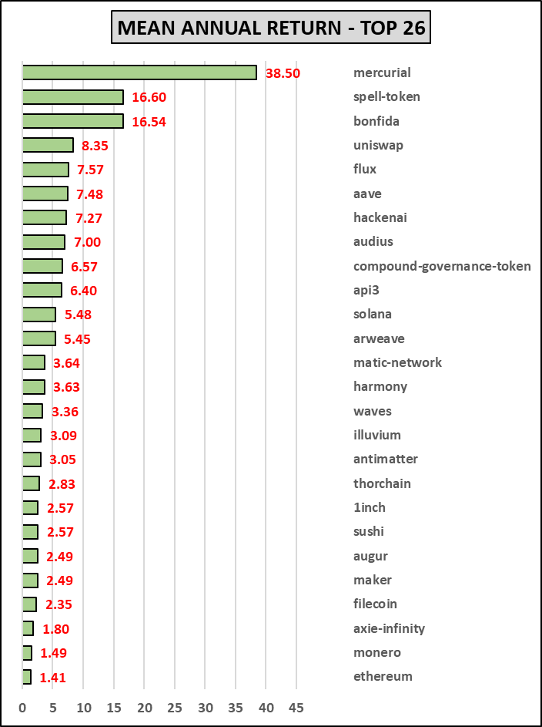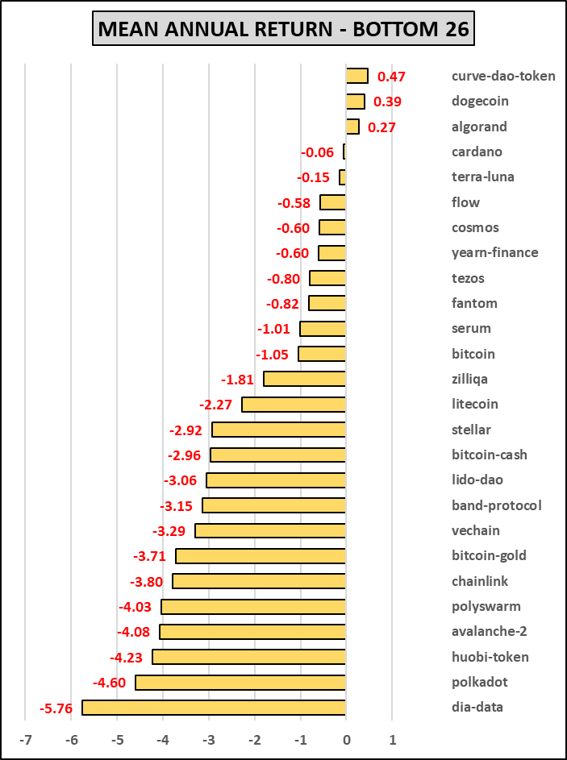

**MEAN VOLATILITY ACROSS ALL FOUR MODELS**

**# OF MODELS (out of 4) WITH POSITIVE ANNUAL RETURN**

